<IPL Data Analysis>

A Project Report

Submitted in the partial fulfillment of the requirements for the award of the degree of

# Bachelor of Technology in

Department of Computer Science and Engineering

By

C.Koushik Reddy (2010030027)

D.Chaitanya (2010030045)

MTV Soumith (2010030097)

under the supervision of

# < Dr.K.Sreenivasa Rao>



Department of Computer Science and Engineering

K L University Hyderabad,

Aziz Nagar, Moinabad Road, Hyderabad – 500 075, Telangana, India.

March, 202

**Declaration**

The Project Report entitled “<IPL Data Analysis>”is a record of bonafide work of < 2010030027,2010030045,2010030097>, submitted in partial fulfillment for the award of B.Tech inthe Department of Computer Science and Engineering to the K L University, Hyderabad. The results embodied in this report have not been copied from any other Departments/University/Institute.

<Signature of the Students >

**Certificate**

This is to certify that the Project Report entitled “<IPL Data Analysis>” is being submitted by < 2010030027,2010030045,2010030097> submitted in partial fulfillment for the award of B.Tech in <Name of the Discipline> to the K L University, Hyderabad is a record of bonafide work carried out under our guidance andsupervision.The results embodied in this report have not been copied from any otherdepartments/ University/Institute.

## Signature of theSupervisor

Name andDesignation

## Signature oftheHOD Signature of the ExternalExamine

**ACKNOWLEDGEMENT**

We take grateful opportunity to thank our beloved Founder and Chairman who has given constant encouragement during our course and motivated us to do this project. We are grateful to our Principal **Dr. L. Koteswara Rao** who has been constantly bearing the torch for all the curricular activities undertaken by us.

We pay our grateful acknowledgement & sincere thanks to our Head of the Department **Dr. Chiranjeevi Manike** for his exemplary guidance, monitoring, and constant encouragement throughout the course of the project.

I express my sincere thanks to our project supervisor <**Dr.K.Sreenivasa Rao**> for his novel association of ideas, encouragement, appreciation and intellectual zeal which motivated us to venture this project successfully.Finally, it is pleased to acknowledge the indebtedness to all those who devoted themselves directly or indirectly to make this project report success.

## Abstract

Sports play a very significant role in the development of the human persona. Getting involved in games like Cricket and other various sports help us to build character, discipline, confidence, and physical fitness. Indian Premier League, IPL provides the most successful form of cricket as it gives opportunities to young and talented players to show case their talents on various pitch. Decision-makers are the utmost customers for all fundamentals in the sports analytics framework. Sports analytics has been a smash hit in shaping success for many players and teams in various sports. Sports analytics and data visualization can play a crucial role in selecting the best players for a team. This project is about the IPL Matches Score Predictor and the breadth of data visualization in supporting the decision makers for identifying inherent players for their teams.

## Table of contents

Page Numbers

Declaration 2

Certificate 3

Acknowledgement 4

## Abstract 5

Introduction 7

Literature Survey 8

Hardware & Sotfware requirements 9

Data Set 10

Proposed System 11

Implementation 12-15

Results Discussion 16

Conclusion and FutureWork 17

**Introduction**

Sports analytics and Data Visualization has provided a greater platform for Player selectors, managers and also the players to increase on field performance. Decision makers and analysis, the next piece of the framework, is the process of applying statistical tools and algorithms to data to gain insight into what is likely to happen in the future. Sports analytics is being applied in various sports like Soccer, basketball and cricket. Each movement of the ball, the player strike rate, run rate, everything is captured using special camera systems and other recording mechanisms. This data is run through various statistical algorithms, tools and visualization techniques to provide deeper insight and pave way for recommendations to the player or team. With the ease of obtaining and storing data, advanced analytics and machine learning techniques are applied to engineer a predictive model for various team sports like cricket. There are three versions of cricket – Test matches, One-day Internationals and Twenty20. Test Cricket is one of the highest-level formats which is played bettween two countries over the duration of five days, ODI is considered as a limited over formats of cricket and T20 is one of the latest and successful forms of cricket. The T20 format gave birth to Indian Premier League (IPL) a professional league contested during April and May of every year. It was initiated by BCCI (Board of Control for Cricket in India) in 2008. This shorter version of cricket is one of the most successful one in terms of fan engagement and business. Everyone enjoys this shorter version of cricket.

**Literature Survey**

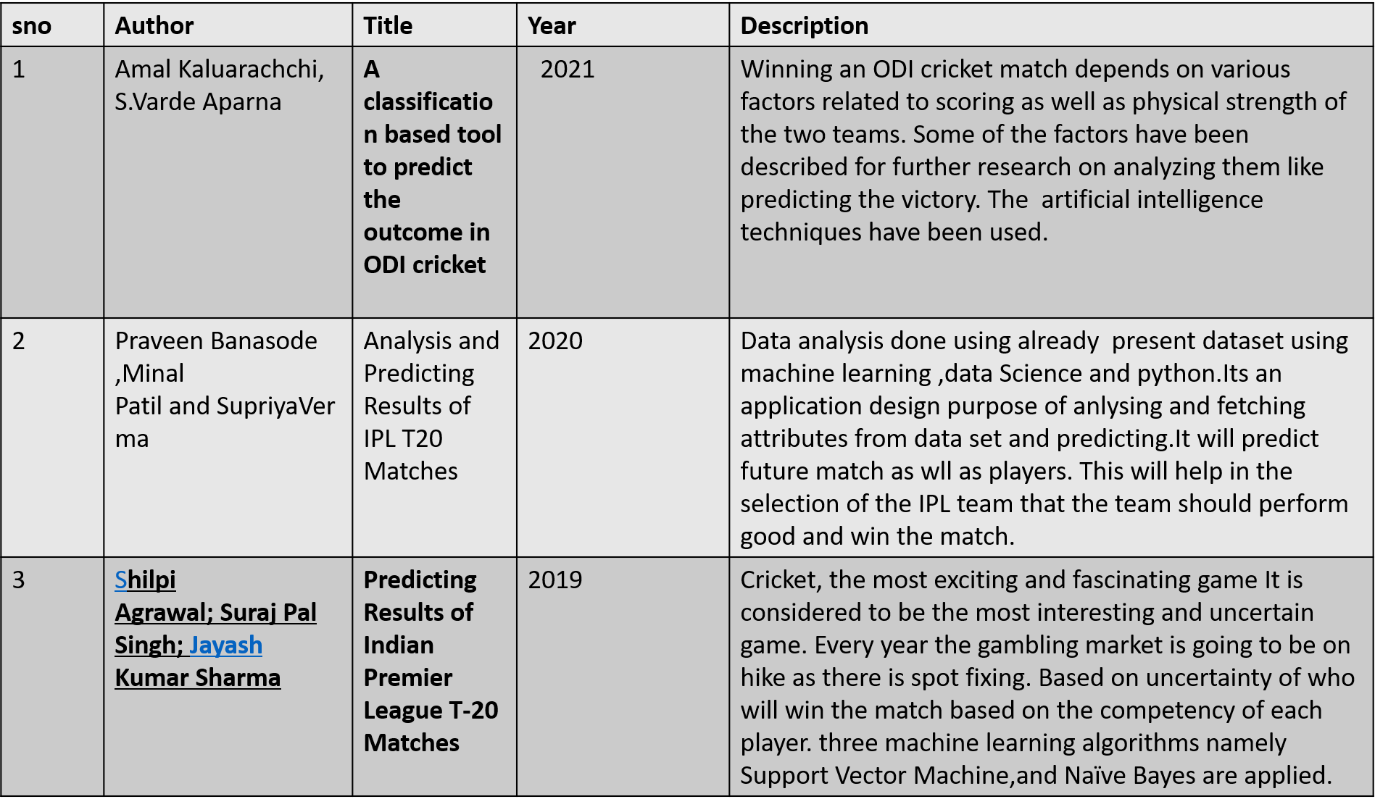

**Hardware & Sotfware requirements**

**Component Minimum requirement**

Processor :64-bit, four-core, 2.5 GHz minimum per core (If your dataset size is significantly larger than the medium dataset, we recommend 8 cores.)

RAM :4 GB

Hard disk :80 GB

Windows 10 (recommended)

**Software:**

* We will be using Python Language to develop this project.
* The libraries we are going to use are pandas, matplotlib, seaborn etc.

**Data Set**

**Proposed System**

**In the proposed system we are going to analyse : -**

* Season wise IPL matches.
* Most matches Played in a venue.
* Matches won by each team.
* IPL matches played by each team.
* Most runs scored by IPL team and players.
* Average runs by teams in powerplay.
* Most Century and fifty's by each player.
* Most 4’s and 6’s by team and player.
* Highest Individual score by player.
* Most wickets taken by player and many more analysis.
* We are also going to build a prediction model which will predict the score based on the past IPL data.

**Implementation**

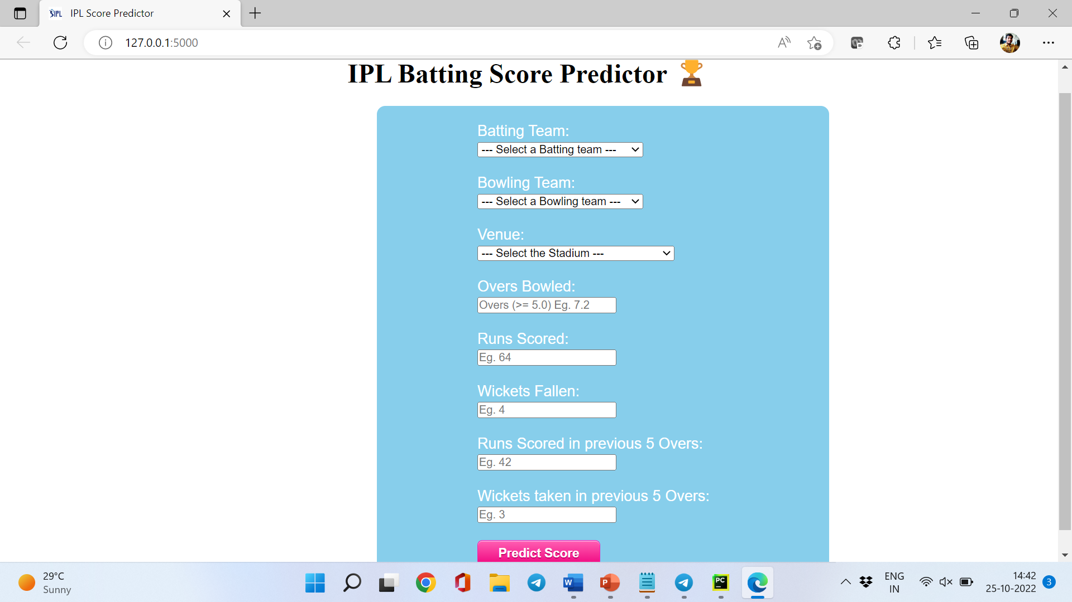

* Here we need to enter the details and based on that prediction will be done.

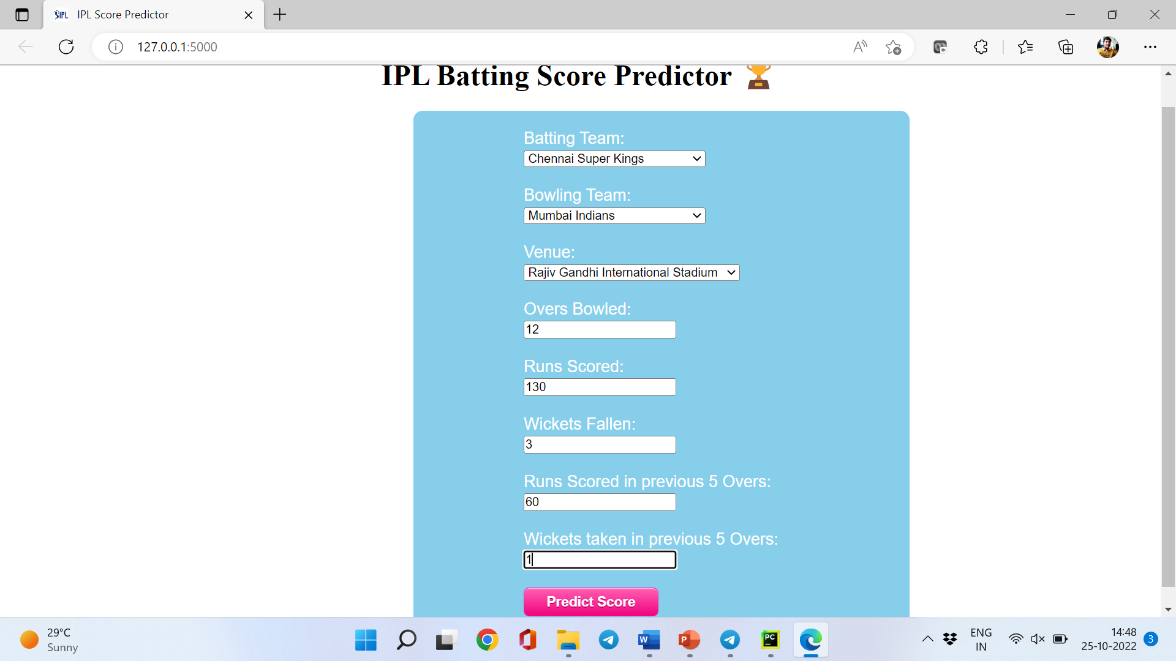

* After entering the details, we should click on predict score then the score will be predicted.

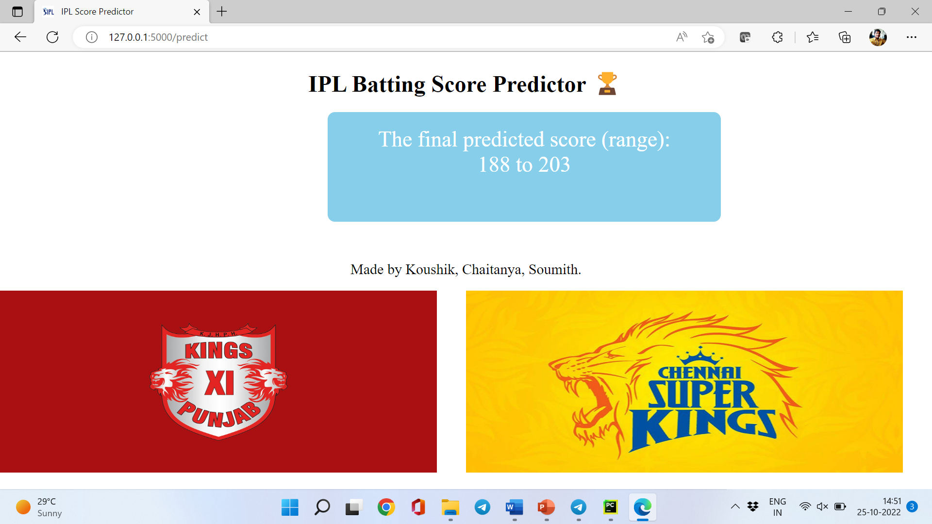

* The Score will be predicted as shown above.
* The below pictures are query-based data visualization.

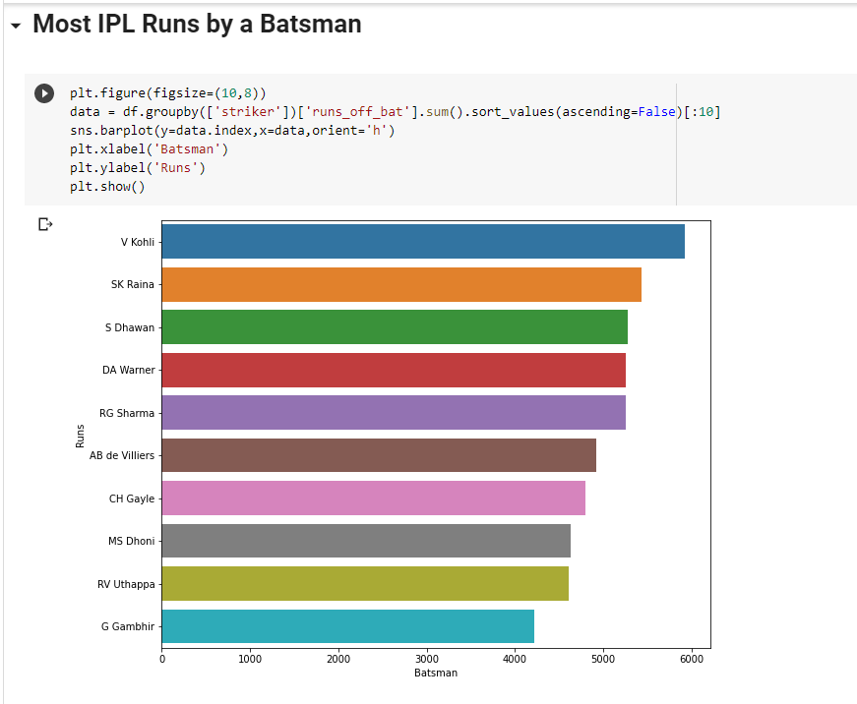

**Results Discussion**

* Our main idea of this project is to build a prediction model.
* So, we have built a score prediction model using  lasso (least absolute shrinkage and selection operator; also Lasso or LASSO) it is a regression analysis method that performs both variable selection and regularization in order to enhance the prediction accuracy and interpretability of the resulting statistical model.
* We must enter few details such as batting team name, bowling team name, Venue, Overs Bowled, Runs Scored, Wickets fallen, Runs scored in last 5 overs, Wickets taken in last 5 overs.
* By the entered data our prediction model will predict the range of runs (ex: -180-202).

**Conclusion and FutureWork**

* Hearby by we conclude that by using our project we can get accurate final scores.
* We also did many data analysis which shows who was the leading run scorer in each season,which team scored more runs in powerplay etc.,
* In the future we can make many more prediction models like winner prediction model etc.,
* And also in future we can also make the model more accurate by adding more data and using different algorithms.